

VistA Imaging System

TeleReader Configurator User Guide

Version 3.0, Patch 127
July 2012– Revision 28

MAG*3.0*127 TeleReader Configurator User GuideTeleReader Configurator User Guide
July 2012July 2012

Property of the US Government
 This is a controlled document. No changes to this document may be made without the express written consent of the VistA Imaging development office.
While every effort has been made to assure the accuracy of the information provided, this document may include technical inaccuracies and/or typographical errors. Changes are periodically made to the information herein and incorporated into new editions of this document.
Product names mentioned in this document may be trademarks or registered trademarks of their respective companies, and are hereby acknowledged.
VistA Imaging Office of Enterprise Development
Department of Veterans Affairs
Internet: http://www.va.gov/imaging
VA intranet: http://vaww.va.gov/imaging

Revision History
Rev | Date | Notes | Notes
1.2 | 07-06-2012 | Updated for TeleReader Configurator User Guide Patch 127. Added true figure and table captions; adopted use of unique font for buttons, keys, etc., and enclosed them in brackets as shown in Document Conventions table. Includes reference to profile cloning capability. Provides:  - Ability to view all TIU consult class templates, versus the limited set previously available  - Ability to modify optional procedure field and maintain the single record session  - Capability for application to check the integrity of the TELEREADER ACQUISITION SERVICE file (#2006.5841)  - Compatibility with the Windows 7 operating system | N. Topalov  VJ McDonald
1.1 | 05-11-2011 | Updated for National Release P106, new section added called “Configuring TeleReader with a Thin Client”. | D. White
1.0 | 08-26-2010 | Updated for National Release. | S.Davis
0.9f | 08-19-2010 | Updated Unread List Page. | B. Balshem
0.9e | 08-18-2010 | Replaced Reader Page Screen Shot with correct spelling of Privilege. | B. Balshem
0.9d | 08-11-2010 | Updated for Release. | S. Davis
0.9c | 08-10-2010 | Made some additional formatting changes. | S. Davis
0.9b | 08-04-2010 | 2nd iteration based on 1st product review comments | B. Balshem, S. Davis
0.9a | 07-20-2010 | Initial draft. | B. Balshem, S. Davis

Contents

Introduction 1
Terms of Use 1
Documentation Conventions 1
VistA Imaging Configuration for TeleReader 2
Using TeleReader Configurator 5
Menus 5
System Help File 5
Field Help Text 5
TeleReader Configurator Main Screen 5
System Message Log 6
About Box 8
Configuring an Acquisition Site 9
Configuring the TeleReader Unread List 9
Adding a Consult Type to the TeleReader Unread List 10
Editing a Consult Type 11
Deleting a Consult Type from the Unread List 11
Configuring the Modality Worklist 11
Adding a Consult Type to the Modality Worklist 12
Adding Clinics to a Modality Worklist Consult Type 13
Editing a Modality Worklist Consult Type 14
Deleting a Modality Worklist Consult Type 15
Configuring a Reading Site 16
Configuring Rights to Acquisition Sites 16
Adding an Acquisition Site 16
Editing, Activating/Deactivating an Acquisition Site 17
Deleting an Acquisition Site 18
Configuring TeleReader Readers 18
Adding New TeleReader Readers 19
Adding Additional Privileges to a Reader 19
Activate/Deactivate Privileges 20
Deleting a Reader or Reader Privilege 21
Configuring TeleReader Global Settings 22
Configuring TeleReader with a Thin Client 23

This page intentionally left blank.

Introduction

This document explains how to configure the Veterans Health Information Systems and Technology Architecture (VistA) Imaging (VI) TeleReader application using the TeleReader Configurator application. The document describes configuration for both the acquisition and reading sites.
This document is meant for site administrators to assist in configuring the TeleReader. This document does not contain information for end-users of the TeleReader. Those users should consult the new TeleReader User Guide (when available).

Terms of Use
FDA regulations require that each Imaging software distribution is documented and tracked by the VistA Imaging project.

Documentation Conventions
The following conventions are used in this document.
Convention | Description
Monospace Type | System-generated menu, dialog, output, etc. (in VistA screenprints)
Bold Type | User Keyboard Entry (in VistA screenprints)
[XTSUMBLD-CHECK] | Routines, VistA Menu options
[OK], [Cancel] |  | Buttons on screen which you click with the mouse
<Enter> |  | Enter (Return) key
<Shift> |  | Shift key
<A>, <2>, <F2> |  | Alpha, numeric or function key
<A>, <2>, <F2> |  | Alpha, numeric or function key
<A>, <2>, <F2> |  | Alpha, numeric or function key
<Esc> |  | Escape key
<Num Lock> | 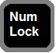 | Top left key on the numeric keypad (above the 7); may also be labeled <Numeric Lock>. It is equivalent to the <Caps Lock> used for alphabetic keys.
<Num Lock> | If <Num Lock> is on, the keypad key will produce the number shown on its surface.  If <Num Lock> is off, the keypad key moves the cursor as indicated by the label or symbol on the key; for example, the keypad <6> key will move the cursor to the right.

This page intentionally left blank.

VistA Imaging Configuration for TeleReader

The TeleReader works in conjunction with the VistA Consult Request Tracking package (namespace = MRC) to enable a user to obtain a list of imaging studies that are ready to be interpreted. Configuration work is required at both the Acquisition Site and the Reading Site.
The TeleReader was first introduced in MAG*3.0*46 and included instructions for configuration using VA FileMan, the VistA database management system. The TeleReader Configurator was developed to replace VA FileMan as the preferred method for configuring the TeleReader. TeleReader Configurator is a windows-based application that eliminates the need for a site administrator to directly access VistA files and fields. The TeleReader Configurator will help you preserve data integrity, and using the application is highly recommended over making manual FileMan changes.

This page intentionally left blank.

Using TeleReader Configurator

Menus
Menus are available on several screens within the application that consist of:
File: The File Menu contains items that are equivalent to buttons on that screen and an option to close the screen, or in the case of the main screen, exit the application.
Help: The Help Menu contains an item ‘Contents’ which opens the system help file. On the TeleReader Main Screen, the Help Menu also contains Message Log and About Box.

System Help File
As mentioned in the Menus section, the system help file can be accessed from the Contents menu item under Help on any screen that contains a menu. In addition, the system help file can be accessed from any screen by pressing the <F1> key.
NOTE: On screens that add or edit configuration settings, when focus is on a control that is tied to a specific field, for example, a combo box (frequently referred to as a “drop-down list”), the <F1> key will invoke help text for that field instead of the system help file. This is explained in the Field Help Text section.

Field Help Text
Any screen that adds or edits configuration settings will have “help text” available for each field on that screen. To invoke the help text for that field, either press the <F1> key while focus is on that control (combo box, edit box) or click on the icon above it to the right.
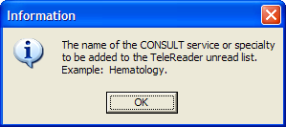
Figure 1 – Field Text Help

TeleReader Configurator Main Screen
From the TeleReader Configurator Main Screen, you have the option to configure Acquisition Site Settings, Reading Site Settings and Global Settings.
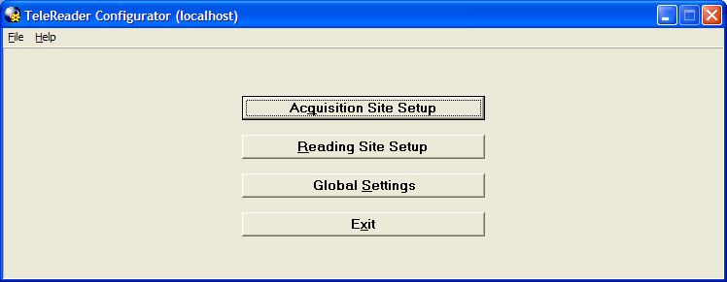
Figure 2 – TeleReader Configurator Main Screen

The [Acquisition Site Setup] button opens the Acquisition Site Consult Setup Screen.

The [Reading Site Setup] button opens the Reader Setup Screen.
The [Global Settings] button opens the TeleReader Global System Settings Screen.
In addition to the standard ‘Contents’ menu item, The TeleReader Configurator Main Screen Help Menu contains selections to view the System Message Log and Application About Box. The Main Screen title bar displays the login server in parentheses.

System Message Log
From the TeleReader Configurator, under the Help Menu, click Message Log.
The View Log File Screen opens.
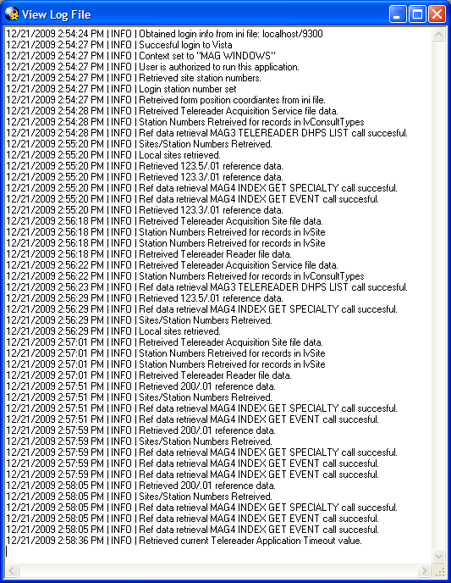
Figure 3 – View Log File Screen

The System Log tracks application activity and can be used to troubleshoot problems in the system. The TeleReader Configurator adds information to the log from start up to close. After you close the application, the Log is saved to a .log file in C:\Program Files\VistA\Imaging (or C:\Program Files (x86) on Windows 7) with a timestamp. One Log file is created per session.

NOTE: As the number of files in the directory grows, the administrator can delete the older files as necessary.

About Box

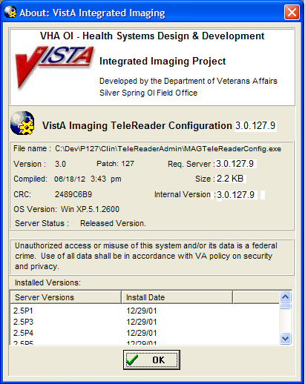
Figure 4 – About Box

The About Box shows information about the application, such as version number.

Configuring an Acquisition Site
Note: | Cloning a TeleReader Profile: Once one or more TeleReader profiles are set up, a Site Manager can then clone those profiles in order to be able to provide consistent profiles for other employees who perform the same function. See the TeleReader User Guide (when available) for details.

To configure an Acquisition Site, from the TeleReader Configurator Main Screen page (see 2) click the [Acquisition Site Setup] button. This opens the Acquisition Site Consult Setup Screen.
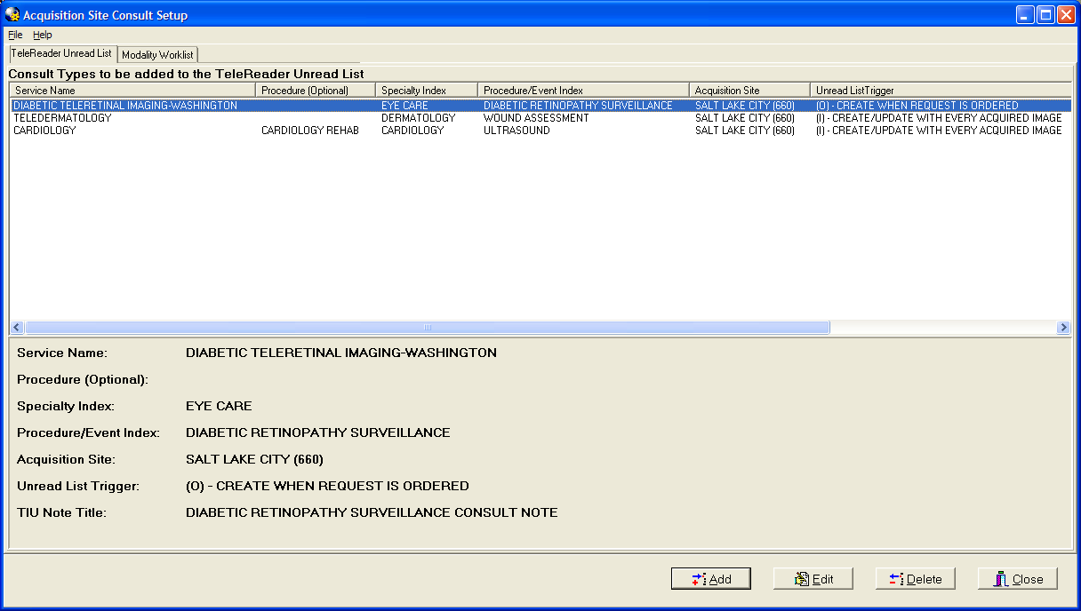
Figure 5 – Acquisition Site Consult Setup Screen

The Acquisition Site Consult Setup Screen has two “pages,” known as tabs.
 | Use the TeleReader Unread List tab to specify which Consult Types VistA Imaging will add to the TeleReader Unread List when a Consult is ordered. This is the default tab when the screen is opened.
Note: | The application provides an exclusive lock for the patient record when selected from the unread List. This allows only that first User to result for that case. Other users who attempt to access the record will receive a message notifying them that the file is read-only and cannot be edited.
 | Use the Modality Worklist tab to specify which Consult Types will be added to the DICOM Modality Worklist when a Consult is ordered.

Configuring the TeleReader Unread List
The TeleReader Unread List tab (see 5) displays all Consult Types currently configured to appear on the TeleReader Unread List. Only the Consults listed here are configured for use with the TeleReader. The bottom panel shows the detail of the selected Service Name. The display is updated as Consult Types are added to /edited/deleted from the TeleReader Unread List.

Adding a Consult Type to the TeleReader Unread List
To add a new Consult Type to the TeleReader Unread List, click the [Add] button on the TeleReader Unread List tab. The Add TeleReader Consult Type Dialog appears.
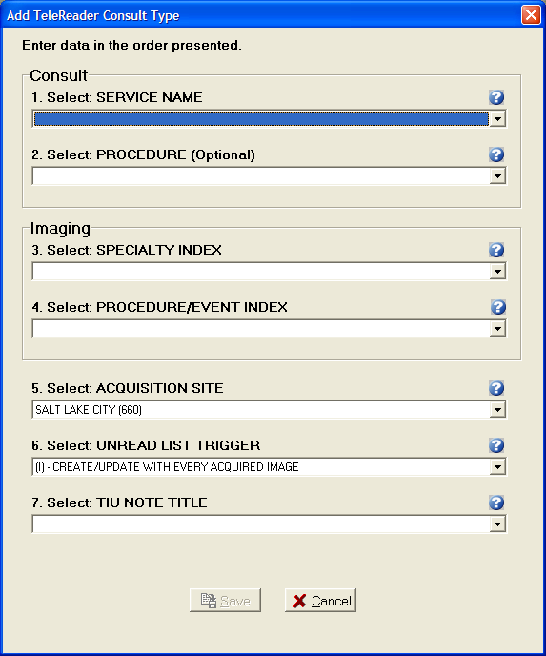
Figure 6 – Add TeleReader Consult Type Dialog

The Add TeleReader Consult Type Dialog has the following six required fields and one optional field:
Table 1 – Add TeleReader Consult Type Dialog
Field Name | Description
Service Name | Service Name of the Consult Type to be added to the Unread List.
Procedure | This field is optional. The drop down list of procedures will be a subset of the selected Service Name.
Specialty Index | Specialty Index of the Consult Type to be added to the Unread List.
Procedure/Event Index | The drop down list will be a subset of the selected Specialty Index.
Acquisition Site | The Acquisition Site defaults to the Login site.
Unread List Trigger | Unread List Trigger defaults to (I) – CREATE/UPDATE WITH EVERY ACQUIRED IMAGE.
TIU Note Title | The Text Integration Utilities (TIU) note to be associated with the consult.

→ When a selection is made for all required fields, the [Save] button is enabled.

Editing a Consult Type
To edit the values of a Consult Type from the TeleReader Unread List page (see 5), select the Service Name then click the Edit button and the Edit TeleReader Consult Type Screen appears.
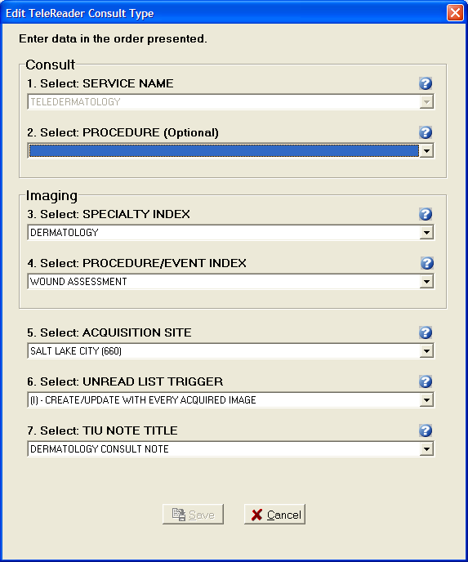
Figure 7 – Edit TeleReader Consult Type Dialog

The Edit TeleReader Consult Type dialog populates with current values of the selected Consult Type. The Service Name combo box is disabled and cannot be changed.
→ Once a change is made to the screen, the [Save] button is enabled.

Deleting a Consult Type from the Unread List
To delete a Consult Type, from the TeleReader Unread List page (see 5) select the Service Name and click the [Delete] button. A dialog appears, askingryou for confirmation. rYou can either…
Click [Cancel] to cancel the action, or…
Click [OK] to confirm the deletion of the Consult Type.

Configuring the Modality Worklist
To configure Consult Types to the Modality Worklist, from the Acquisition Site Consult Setup Screen page (see 5) click the Modility Worklist tab to get to the Modality Worklist tan.
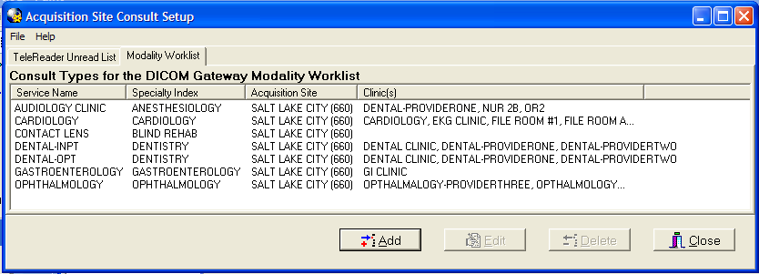
Figure 8 – Modality Worklist Tab

The Modality Worklist tab displays all Consult Types currently configured to appear on the DICOM Modality Worklist when a Consult of that type is ordered. The display is updated as Consult Types are added to /edited/deleted from the Modality Worklist.

Adding a Consult Type to the Modality Worklist
To add a new Consult Type to the Modality Worklist, click the [Add] button on the Modality Worklist tab and the Add Modality Worklist Consult Type dialog appears.
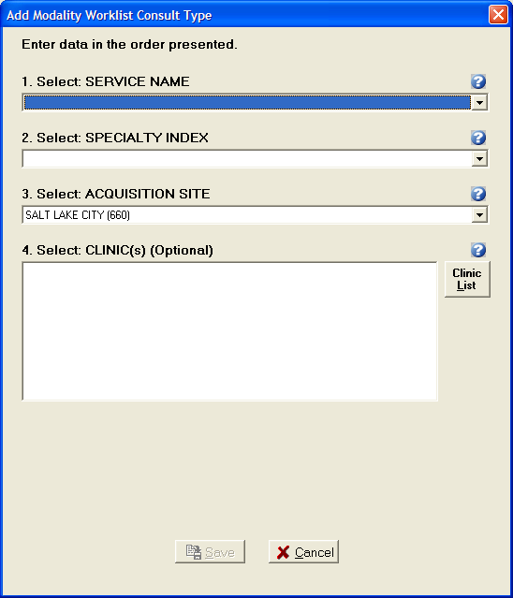
Figure 9 – Add Modality Worklist Consult Type Dialog

The Add Modality Worklist Consult Type dialog has the following three required fields and one optional field:
Service Name: | Service Name of the Consult Type to be added to the Modality Worklist.
Specialty Index: | Specialty Index of the Consult Type to be added to the Unread List.
Acquisition Site: | The Acquisition Site defaults to the login site.
Clinic(s): | The Clinic(s) list box can have one or more selections and is optional. For more instruction on how to add clinics read the section below.

→ When a selection is made for all required fields, the [Save] button is enabled.

Adding Clinics to a Modality Worklist Consult Type
Adding Clinics to a Consult Type means that the information for an appointment scheduled at that clinic of that Consult Type will appear on the Modality Worklist.
 To add clinics to the Consult Type, click the [Clinic List] button; the Select Clinic(s) dialog opens.
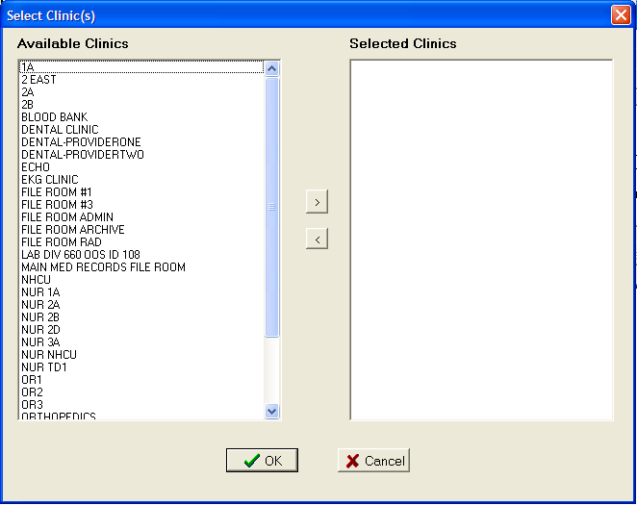
Figure 10 – Select Clinic(s) Dialog

The Select Clinic(s) dialog has two list boxes. Available Clinics displays the list of Clinics that can be associated with the Consult Type. Selected Clinics will display Clinics as you select them to add to the Consult type.
To select a Clinic to be added to the Consult Type, from the Available Clinics list box, either double-click on an item or select the item and click the [>] button. The selected item(s) will move from Available Clinics to Selected Clinics.
To move a Selected Clinic back to the Available Clinics list, either double-click the item in the Selected Clinics list box or select it and click the [<] button.
To save the selections click [OK]. The Select Clinic(s) dialog closes and the Clinic(s) list box on the Add Modality Worklist Consult Type dialog will display the selected Clinics.

Editing a Modality Worklist Consult Type
To edit the values of a Modality Worklist Consult Type, from the Modality Worklist tab (see 8) select the Service Name then click the [Edit] button and the Edit Modality Worklist Consult Type Screen appears.
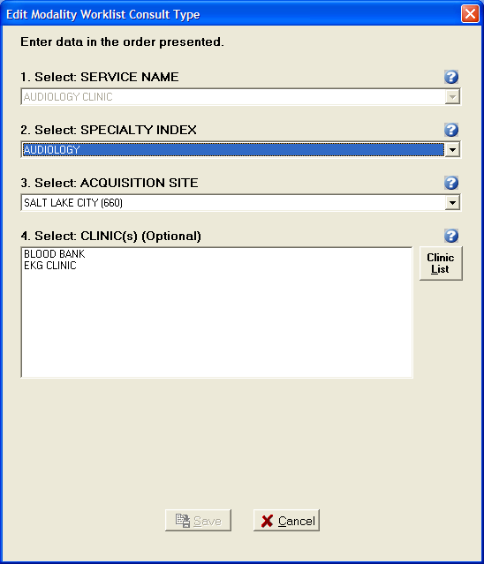
Figure 11 – Edit Modality Worklist Consult Type Dialog

The Edit Modality Worklist Consult Type dialog populates with current values of the selected Consult Type. The Service Name combo box is disabled and cannot be changed.

→ Once a change is made in the dialog box, the [Save] button is enabled.

Deleting a Modality Worklist Consult Type
To delete a Modality Worklist Consult Type, on the Modality Worklist Screen (see 8) select the Service Name and click the Delete button. A dialog appears, askingryou for confirmation.rYou can either
Click [Cancel] to not delete the Consult Type, or…
Click [OK] to confirm the deletion of the Consult Type.

Configuring a Reading Site
Note: | Cloning a TeleReader Profile: Once one or more TeleReader profiles are set up, a Site Manager can then clone those profiles in order to be able to provide consistent profiles for other employees who perform the same function. See the TeleReader User Guide (when available) for details.

To configure a Reading Site, from the TeleReader Configurator Main Screen page (see 2) click the Reading Site Setup button. This opens the Reader Setup Screen.
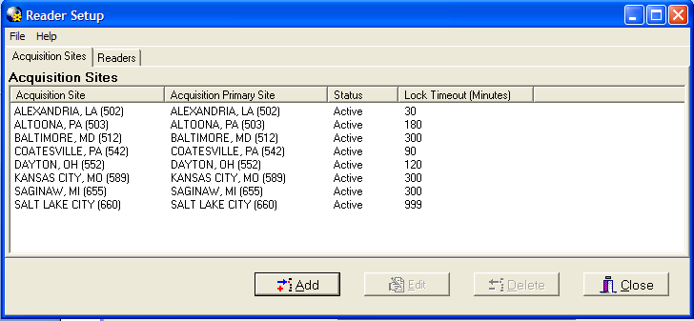
Figure 12 – Reader Setup Screen

The Reader Setup Screen has two pages. The Acquisition Sites page configures which Acquisition Sites’ Unread List local Readers have rights too. This is the default page when the screen is opened.
The Readers page configures user level rights to Acquisition Sites’ Unread List.
NOTE: At the user level, rights are referred to as Privileges.

Configuring Rights to Acquisition Sites
The Acquisition Sites page (see 2) displays all Acquisition Site Unread Lists for which local Readers have rights. The display is updated as Acquisition Site rights are added, edited or deleted for local Readers.

Adding an Acquisition Site
To add a new Acquisition Site, click the [Add] button on the Acquisition Site page and the Add Acquisition Site Dialog appears.

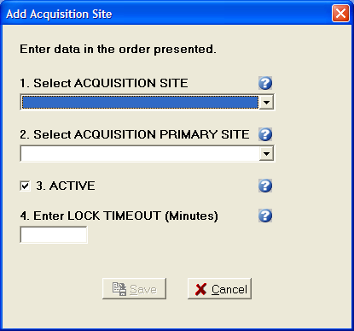
Figure 13 – Add Acquisition Site Dialog

The Acquisition Site Dialog has the following four required fields:
Acquisition Site: The acquisition site where the Unread List Consults were ordered.
Acquisition Primary Site: The primary site of the acquisition site.
Active: Status of the acquisition site. If the status is not active, local Readers will not be able to result Consults from that sites Unread List through TeleReader. The Active checkbox defaults to checked (the Rights to that site are active).
Lock Timeout: Lock Timeout configures the amount of time (in minutes) a consult will remain locked on the Unread List before automatically unlocking.

→ When all fields are completed, the [Save] button is enabled.

Editing, Activating/Deactivating an Acquisition Site
To edit the values or change the Active Status of an Acquisition Site, from the Acquisition Site page (see 2) select the Site then click the Edit button and the Edit Acquisition Site Dialog appears.
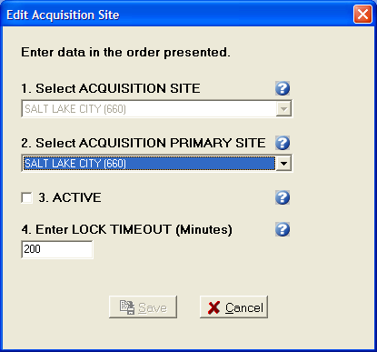
Figure 14 – Edit Acquisition Site Dialog

The Edit Acquisition Site Dialog populates with the current values of the selected Acquisition Site. The Acquisition Site combo box is disabled and cannot be changed.
Once a change is made to the screen the Save button is enabled. To deactivate the site to local Readers uncheck the Active check box. To reactivate the site at a later time, open the Edit Acquisition Site Dialog for the site and check to Active check box.

Deleting an Acquisition Site
To delete an Acquisition Site, on the Acquisition Site page (see 2) select the Site and click the [Delete] button. A dialog appears, askingryou for confirmation. rYou can either Cancel the action or click OK to confirm the deletion of the Acquisition Site.

Configuring TeleReader Readers
To configure a Reader for TeleReader from the Reader Setup Screen (see 2), click the Readers tab to get to the Readers/Privileges tae.
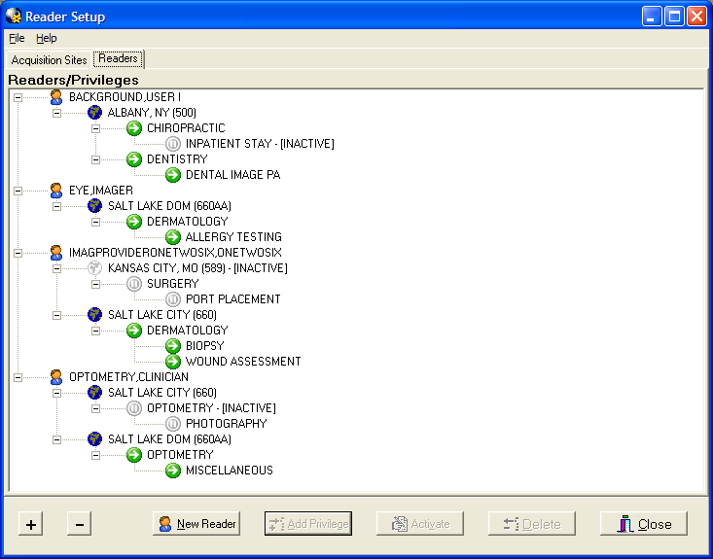
Figure 15 – Reader Setup (Readers/Privileges)

The Readers/Privileges Screen displays the Readers configured to read TeleReader Consults and the specialties/procedures assigned to them. Any user who needs to use TeleReader must be configured on this page to have access to the unread list. The view can be collapsed by clicking the (-) button and expanded (as shown in Figure 12) by the clicking the (+) button. The screen opens with an expanded view.
As Readers/Reader Privileges are added/deleted/activated/inactivated the view is updated.

Adding New TeleReader Readers
To add a new Reader, from the Reader page, click the New Reader button and Add New Reader Dialog appears.
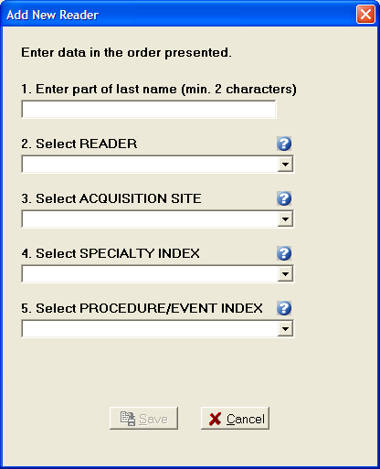
Figure 16 – Add New Reader Dialog

The Add New Reader Dialog has the following four required fields and a Reader lookup edit box:
Reader: When adding a new Reader, enter a partial last name (at least first 2 characters) in the first edit box and press ENTER. The Reader combo box drop down will be the populated with the list of matches against the last name string. The first match in the list (alphabetically) will default as the selection.
Acquisition Site: The drop down list of sites will be those added to the Acquisition Site page.
Specialty Index: Specialty Index of the that Acquisition sites Unread List Consult Type.
Procedure/Event Index: The drop down list from the Procedure/Event Index combo box will be a subset of the selected Specialty Index.
When all fields are completed, the Save button is enabled.

Adding Additional Privileges to a Reader
To Add Privileges to an existing Reader select the appropriate Privilege from the Screen (see 5) view and click the Add Privileges button. The Add to Dialog opens.
For example, to add a new Acquisition Site for a Reader, select the Reader on the view and click the Add Privilege button. To a new Specialty one of the Reader’s Acquisition Site, select the Acquisition Site then click the Add Privilege button. To Add a new Procedure to an Exiting Reader/Acquisition Site/Specialty select that Specialty.
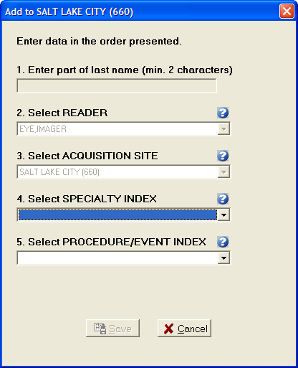
Figure 17 – Add to (Reader Privileges) Dialog

In Figure 14 you are adding a new Specialty to the Salt Lake City Acquisition Site for Reader Eye, Imager. That Privilege (Acquisition Site) and all higher level Privileges (Reader) are disabled and cannot be changed. Because the Reader cannot be changed, the Reader lookup edit box is disabled as well. When all required selections on the dialog are completed the Save button is enabled.

Activate/Deactivate Privileges
To activate/deactivate a Privilege on the Readers/Privileges view (see 5), select the appropriate Privilege and click the [Activate/Deactivate] button. The button’s text will display Activate when the selected Privilege is inactive, and will display Deactivate when on an Active Privilege.
Readers do not have an active status. When a Reader is selected, the [Activate/Deactivate] button will be disabled.

Explicit/Implicit Deactivation
When you Deactivate an Active Privilege, then all Child Privileges arewilactivated as well. All Deactivated Privileges will have an icon change for their given node: a (grayed out globe for Acquisition Site, Gray Pause button for Specialty Index, Procedure index). The explicitly Deactivated Privilege will have the text [INACTIVE]’ apended to it. To Activate the Privilege and its Child Privileges select the appropriate node and click Activate. The Privilege and all Child Privilege will become Active with the icon changing (colored in globe, green play button) and the [INACTIVE] text removed.
NOTE: If a Child Privilege had been explicitly deactivated at an earlier time, it will remain so, even after the Parent Privilege is activated until the Child Privilege is explicitly activated.

Deleting a Reader or Reader Privilege
To Delete a Reader or Reader Privilege from the Reader Setup page (see 5) select that Reader/Reader Privilege and click the [Delete] button. A dialog appears, askingryou for confirmation. r
You can either [Cancel] the action, or…
Click [OK] to confirm the deletion.
If a Reader or Privilege is deleted all sub Privileges will be deleted as well.

Complete Privilege Set
Each Reader must have at least one Acquisition Site. Each Acquisition Site must have at least one Specialty. Each Specialty must have at least one Procedure. If deleting a Privilege makes a Reader or Parent Privilege incomplete, it will be deleted as well and the confirmation dialog message will state this. For example, if an Acquisition Site Privilege is deleted and is the only Site that Reader has then reader will be deleted as well.
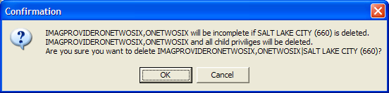
Figure 18 – Reader Privileges Delete (Confirmation Dialog)

Configuring TeleReader Global Settings
To configure Global Settings, from the TeleReader Configurator Main Screen (see 2) click the Global Settings button. This opens the TeleReader Global System Settings Screen.
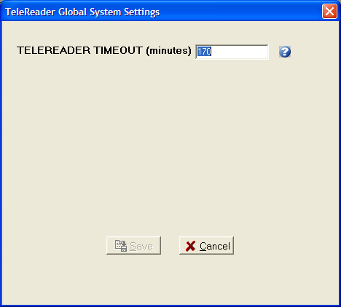
Figure 19 – TeleReader Global System Settings Dialog

At the time of this document, the only setting is TeleReader Timeout in minutes. This setting specifies how long the TeleReader application can stand idle on a desktop before it closes.

Configuring TeleReader with a Thin Client
By default, the TeleReader application is restricted from running on a Thin Client workstation. This restriction can be overridden at various levels with the use of the MAG TR ALLOW THIN CLIENT parameter. To configure this parameter:
- In the VistA menu system, select Kernel menu option XPAR EDIT PARAMETER and parameter MAG TR ALLOW THIN CLIENT.

Select OPTION NAME: XPAR EDIT
1 XPAR EDIT BY TEMPLATE Edit Parameter Values with Template
2 XPAR EDIT KEYWORD Edit Parameter Definition Keyword
3 XPAR EDIT PARAMETER Edit Parameter values
CHOOSE 1–3: 3 XPAR EDIT PARAMETER Edit Parameter Values
Edit Parameter Values

--- Edit Parameter Values ---

Select PARAMETER DEFINITION NAME: MAR TR ALLOW THIN CLIENT MAG TELEREADER ALLOW THIN CLIENT

MAR TR ALLOW THIN CLIENT may be set for the following:

1 User USR [choose from NEW PERSON]
2 Service [choose from SERVICE/SECTION]
3 Division [choose from INSTITUTON]
4 SYSTEM [IMGDEMO1.MED.VA.GOV]

Enter selection:

Software applications presenting a graphical user interface (GUI) often use buttons, icons, dialogue boxes, and similar devices onscreen. These are called “controls” because they allow you to control actions of the software. A control is said to be “in focus” when your cursor is in or on the field (or on the down arrow for drop-down lists). When you click one of these controls, the application carries out a pre-determined action. This contrasts with a command line interface (like VistA) where communication is by exchange of strings of text.

